How to set up Shader
To set up the double sided material for any foliage that you may wish to import into the scene of your own it is simple and quick to set up.
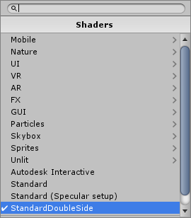
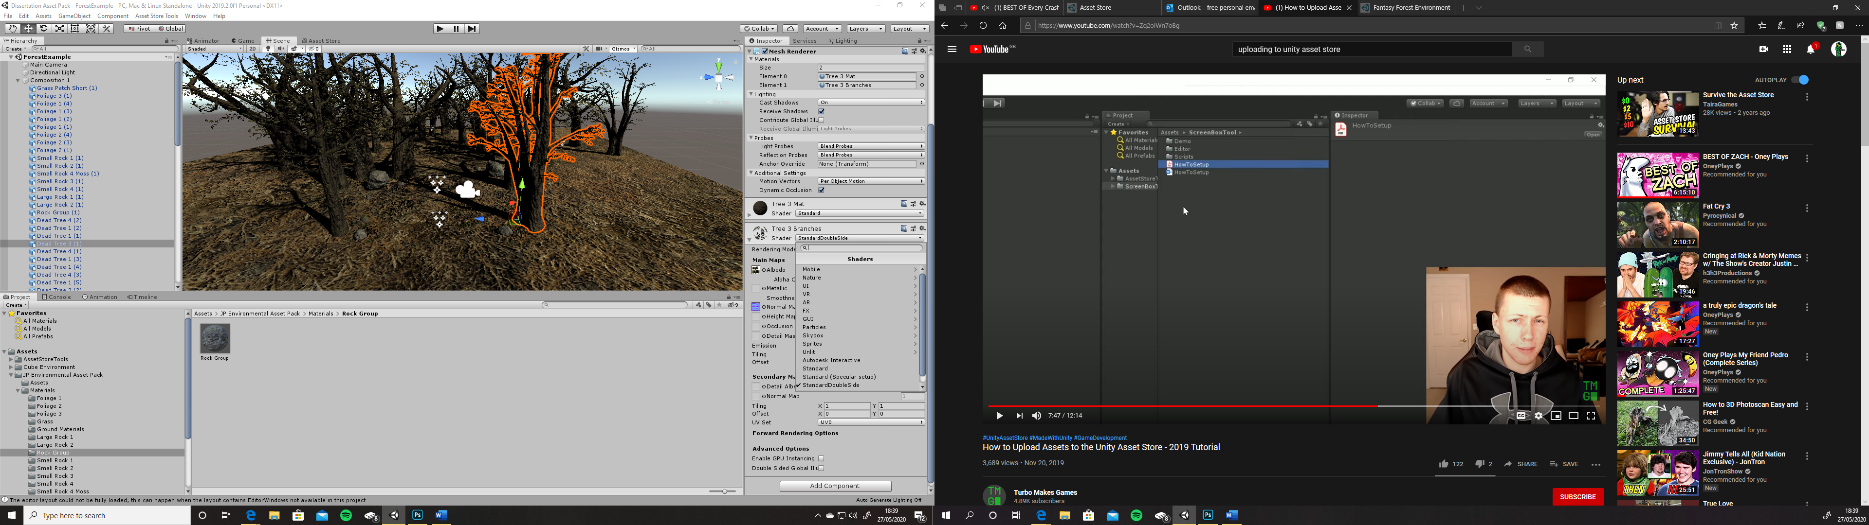
- Select the shader from the drop down menu of your materials shader menu.
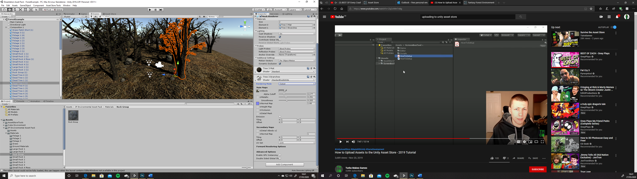
- From here once the shader is selected, change the rendering mode to cut out. This will remove any background colour from your PNG texture. Adjust the Alpha Cut off to your own specification of how much of the texture you wish to be seen.

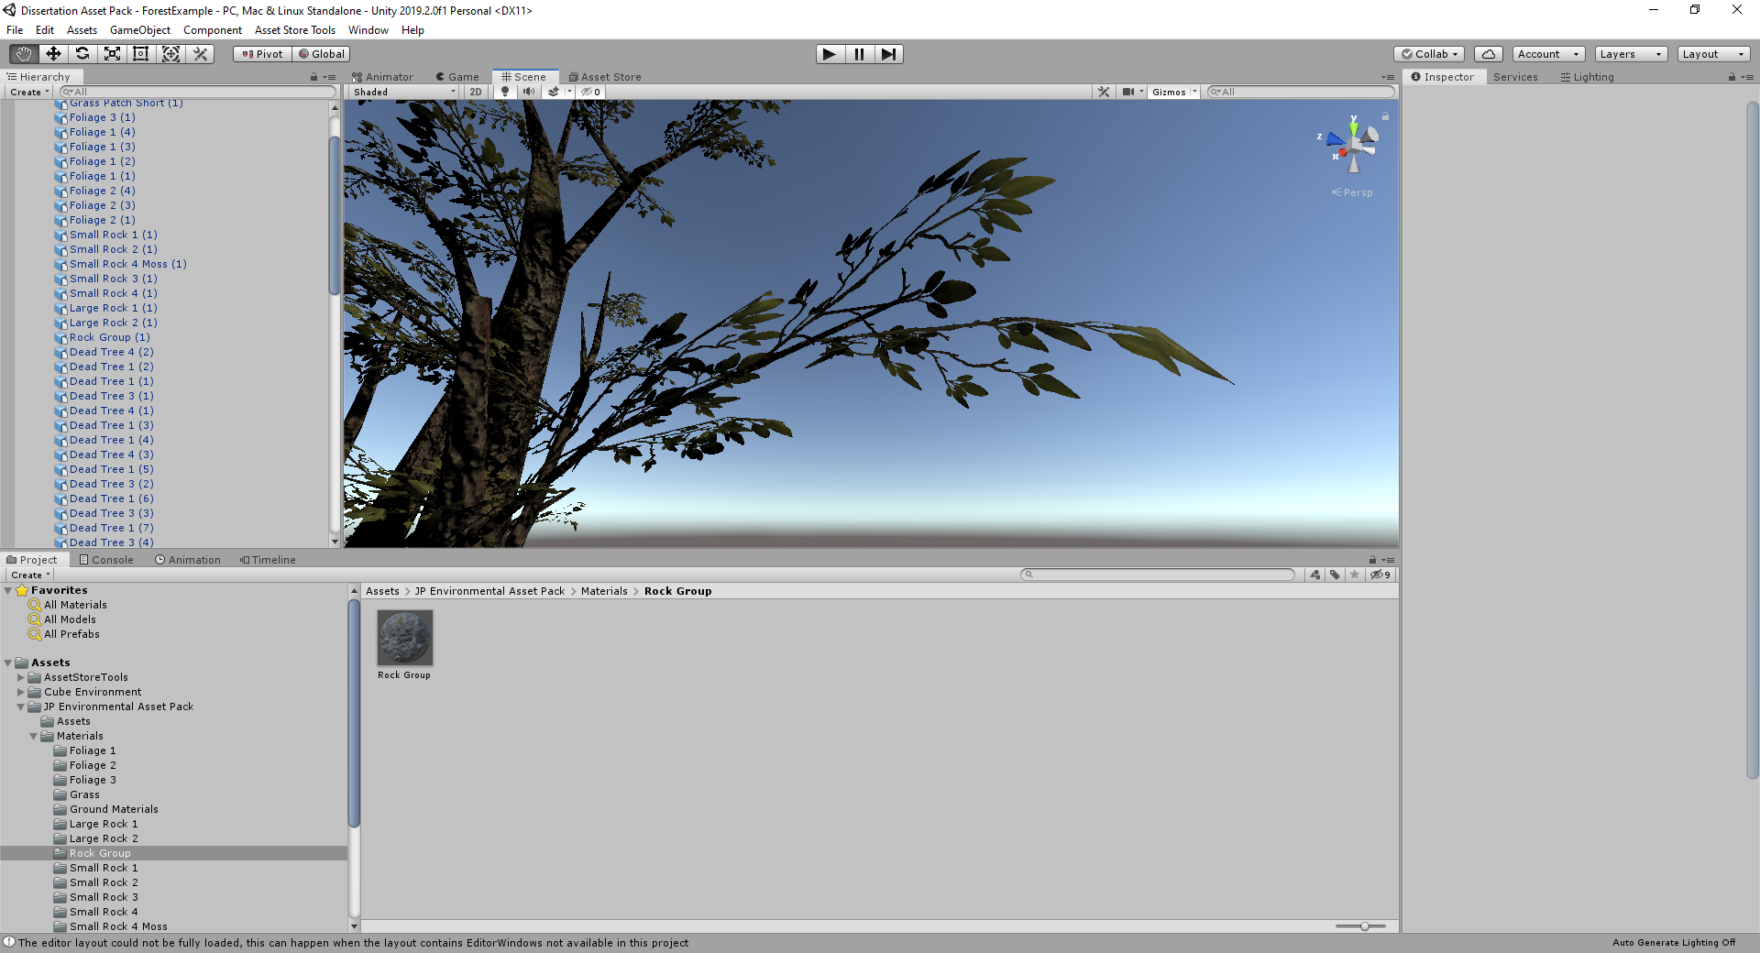
- Apply the rest of your maps accordingly. Once done then you’re all set.

